Requirements and Analysis Document for the Vanaheim
project (RAD)

1 Introduction
1.1 Purpose of application
The purpose of the game is to create a fun environment for the player. By using text to perform things, we hope to help people become better at typing.

1.2 General characteristics of application
The Vanaheim application is a single-player application with a graphical user interface (GUI) for Windows/Mac/Linux platforms.

The player will navigate through a 2-dimensional world. Navigation is made using the arrow keys. When navigating around the world, the player may be blocked by certain objects such as trees, water etc. Every interaction is made by typing commands. For example if the player wishes to equip his axe from the inventory he can type ”equip crude axe”.
The game will not have an end.

1.3 Scope of application
It is only possible to play the game alone. That is, there is no multiplayer option. There is no option to save a game and there is no saved statistics for player level, quests completed etc.

1.4 Objectives and success criteria of the project
- It should be possible to accept and complete a quest. A quest can for example be to kill five spiders.
- It should be possible to use commands to invoke actions in the game.

1.5 Definitions, acronyms and abbreviations
- GUI, graphical user interface
- FPS, frames per second
- Java, platform independent programming language.
- JRE, Java Runtime Environment. Additional software needed to run a Java application.
- Host, a computer where the game will run.
- NPC, non-player character
- Loot, pick up items from killed enemies.
- Quest, a player accepts a quest, performs it and then finishes it to gain a reward.

2 Requirements
2.1 Functional requirements
The player should be able to:
- Move around the world
- Attack monsters
- Kill monsters
- Loot monsters
- Start game from welcome screen
- End game to welcome screen
- Equip items
- Unequip items
- Use items
- Receive quest from NPC
- Complete quest
- Be able to change world, for examle enter a house

2.2 Non-functional requirements
2.2.1 Usability
- Get response from NPC in a resonable amount of time
- Not too high latency that disturb the player
2.2.2 Reliability
NA
2.2.3 Performance
- FPS at 120. Not more not less. Too much FPS and the game will require too much from the users computer and too less the game will feel laggy. 120 FPS is recommended.
2.2.4 Supportability
NA
2.2.5 Implementation
To achieve platform independence, the application will use the Java environment. We use Slick2D library so we can focus on other implementation details.
2.2.6 Packaging and installation
- JAR-files
2.2.7 Legal
- Only use openSource sprites and music. Also some music are made by us.

2.3 Application models
2.3.1 Use case model
See APPENDIX for UML diagram and textual descriptions.

2.3.2 Use cases priority
1. Start game
2. Move around the map
3. Enter houses
4. Exit houses
5. Use simple command tasks
  - Open inventory
  - Close inventory
  - Show questbook
  - Hide questbook
  - Equip an item
  - Unequip item
  - Use item
6. Fight monsters
7. Use more advanced command tasks
  - Open console window
  - Close console window
  - Hit monster
  - Talk to NPC
  - Loot items
8. Win against monster
9. Lose against monster
10. Receive quest from NPC
11. Finish quest
12. End game

2.3.3 Analysis Model
See APPENDIX
2.3.4 User inteface
The application will use a fixed GUI, always at fullscreen and with size 1024x768. This to ensure a good user experience when playing the game. If too small the user can have problems to read certain things and therefor experience a worse game performance.

APPENDIX
Use cases
Overview
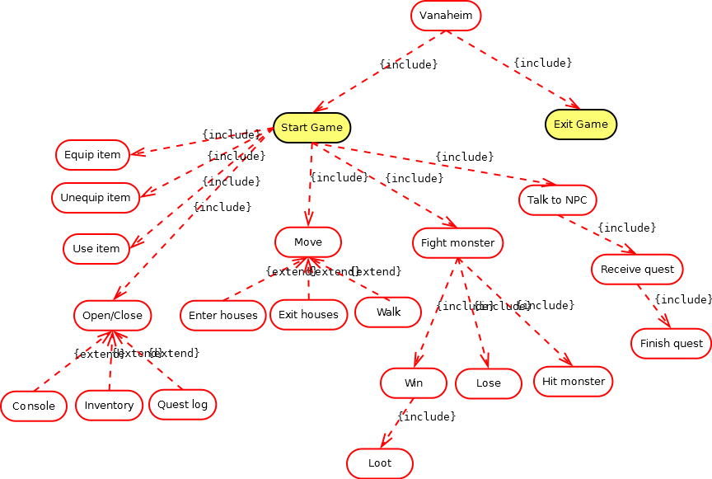

Use case texts
Use Case: (Battle)
Summary: Battle with a monster (a mashup from many usecases)

Priority: mid

Extends: nothing

Includes: Start Game

Participators: Player, Monster

Normal flow of events

+----+-----------------------------+------------------------------+
| | Player | System |
+----+-----------------------------+------------------------------+
+----+-----------------------------+------------------------------+
| 1 |Enter a battle by | |
| |walking on ”wrong” grass tile| |
+----+-----------------------------+------------------------------+
| 2 | | Start a battle with a monster|
| | | generated on tile |
+----+-----------------------------+------------------------------+
| 3 | See a battle sceen with | |
| | player and monster on it | |
+----+-----------------------------+------------------------------+
| 4 | Player need to attack | Play as the monster and try |
| | the monster to win the game | kill the player by at the end|
| | | of time hit the player |
+----+-----------------------------+------------------------------+
| 5 | | End the game. Loser is the |
| | | one with no hp left. |
| | | Drop loot if player win |
+----+-----------------------------+------------------------------+

Alternate flow

Flow 1.1 No monster on tile

+----+---------------+---------------+
| | Player | System |
+----+---------------+---------------+
+----+---------------+---------------+
| 1 | Player walk on| |
| | a tile with no| |
| | monster on it | |
+----+---------------+---------------+
| 2 | |no battle is |
| | |generated |
+----+---------------+---------------+
| 3 | The player can| |
| | still walk and| |
| | remain in same| |
| | world | |
+----+---------------+---------------+

Exceptional flow

+----+---------------+---------------+
| | Player | System |
+----+---------------+---------------+
+----+---------------+---------------+
| 1 | Player walk on| |
| | a tile with | |
| | monster on it | |
+----+---------------+---------------+
| 2 | |Something goes |
| | |wrong |
+----+---------------+---------------+
| 3 | The player can| |
| | still walk and| |
| | remain in same| |
| | world | |
+----+---------------+---------------+

Use Case: (Use item)
Summary: Use a healing potion

Priority: high

Extends: nothing

Includes: Start Game

Participators: Player

Normal flow of events

+----+---------------------------+------------------+
| | Player | System |
+----+---------------------------+------------------+
+----+---------------------------+------------------+
| 1 | Type drink healing potion | |
| | in command line | |
+----+---------------------------+------------------+
| 2 | | Interpret command|
+----+---------------------------+------------------+
| 3 | Heals the player | |
| | | |
+----+---------------------------+------------------+

Alternate flow

Flow 2.1 Given command is not found

+----+----------------+------------------+
| | Player | System |
+----+----------------+------------------+
+----+----------------+------------------+
| 1 | Type a command | |
| | in command line| |
+----+----------------+------------------+
| 2 | | Don't find |
| | | command |
+----+----------------+------------------+
| 3 | Nothing happens| |
| | | |
+----+----------------+------------------+

Flow 2.2 Command not okey at the time (No healing potion in inventory)

+----+-------------------------+----------------------+
| | Player | System |
+----+-------------------------+----------------------+
+----+-------------------------+----------------------+
| 1 | Type use healing potion | |
| | in command line | |
+----+-------------------------+----------------------+
| 2 | | Command not okey |
| | | at this point in time|
+----+-------------------------+----------------------+
| 3 | Nothing happens | |
| | | |
+----+-------------------------+----------------------+

Exceptional flow

+----+---------------------------+---------------------+
| | Player | System |
+----+---------------------------+---------------------+
+----+---------------------------+---------------------+
| 1 | Type drink healing potion | |
| | in command line | |
+----+---------------------------+---------------------+
| 2 | | Something goes wrong|
+----+---------------------------+---------------------+
| 3 |Nothing will | |
| | happen | |
+----+---------------------------+---------------------+

Use Case: (equip item)
Summary: Equip an equippable item from inventory and remove item from inventory
Priority: high

Extends: nothing

Includes: Start Game

Participators: Player

Normal flow of events

+----+---------------------------+------------------+
| | Player | System |
+----+---------------------------+------------------+
+----+---------------------------+------------------+
| 1 | Type equip crude axe | |
| | in command line | |
+----+---------------------------+------------------+
| 2 | | Interpret command|
+----+---------------------------+------------------+
| 3 | equip the crude axe | |
| | | |
+----+---------------------------+------------------+

Alternate flow

Flow 3.1 Given command is not found

+----+----------------+------------------+
| | Player | System |
+----+----------------+------------------+
+----+----------------+------------------+
| 1 | Type a command | |
| | in command line| |
+----+----------------+------------------+
| 2 | | Don't find |
| | | command |
+----+----------------+------------------+
| 3 | Nothing happens| |
| | | |
+----+----------------+------------------+

Flow 3.2 Command not okey at the time (no crude axe in inventory or some item already equipped)

+----+---------------------------+------------------+
| | Player | System |
+----+---------------------------+------------------+
+----+---------------------------+------------------+
| 1 | Type equip crude axe | |
| | in command line | |
+----+---------------------------+------------------+
| 2 | | Interpret command|
+----+---------------------------+------------------+
| 3 | Nothing happens | |
| | | |
+----+---------------------------+------------------+

Exceptional flow

+----+----------------+---------------------+
| | Player | System |
+----+----------------+---------------------+
+----+----------------+---------------------+
| 1 | Type a command | |
| | in command line| |
+----+----------------+---------------------+
| 2 | | Something goes wrong|
+----+----------------+---------------------+
| 3 |Nothing will | |
| | happen | |
+----+----------------+---------------------+

Use Case: (unequip item)
Summary: Unequip item from equipment and place in inventory
Priority: high

Extends: nothing

Includes: Start Game

Participators: Player

Normal flow of events

+----+---------------------------+------------------+
| | Player | System |
+----+---------------------------+------------------+
+----+---------------------------+------------------+
| 1 | Type unequip crude axe | |
| | in command line | |
+----+---------------------------+------------------+
| 2 | | Interpret command|
+----+---------------------------+------------------+
| 3 | unequip the crude axe | |
| | and place in inventory | |
+----+---------------------------+------------------+

Alternate flow

Flow 4.1 Given command is not found

+----+----------------+------------------+
| | Player | System |
+----+----------------+------------------+
+----+----------------+------------------+
| 1 | Type a command | |
| | in command line| |
+----+----------------+------------------+
| 2 | | Don't find |
| | | command |
+----+----------------+------------------+
| 3 | Nothing happens| |
| | | |
+----+----------------+------------------+

Flow 4.2 Command not okey at the time (nothing to unequip och inventory full)

+----+---------------------------+------------------+
| | Player | System |
+----+---------------------------+------------------+
+----+---------------------------+------------------+
| 1 | Type unequip crude axe | |
| | in command line | |
+----+---------------------------+------------------+
| 2 | | Interpret command|
+----+---------------------------+------------------+
| 3 | Nothing happens | |
| | | |
+----+---------------------------+------------------+

Exceptional flow

+----+----------------+---------------------+
| | Player | System |
+----+----------------+---------------------+
+----+----------------+---------------------+
| 1 | Type a command | |
| | in command line| |
+----+----------------+---------------------+
| 2 | | Something goes wrong|
+----+----------------+---------------------+
| 3 |Nothing will | |
| | happen | |
+----+----------------+---------------------+

Use Case: (Move)
Summary: Moves the character on the map

Priority: high

Extends: nothing

Includes: Start Game

Participators: Player

Normal flow of events

+----+---------------+---------------+
| | Player | System |
+----+---------------+---------------+
+----+---------------+---------------+
| 1 | Press an arrow| |
| | -key | |
+----+---------------+---------------+
| 2 | | move character|
+----+---------------+---------------+
| 3 | See the | |
| | char moving | |
+----+---------------+---------------+

Alternate flow

Flow 5.1 Something block the way

+----+---------------+---------------+
| | Player | System |
+----+---------------+---------------+
+----+---------------+---------------+
| 1 | Press an arrow| |
| | -key | |
+----+---------------+---------------+
| 2 | |road is blocked|
+----+---------------+---------------+
| 3 | The char stand| |
| | still | |
| | | |
+----+---------------+---------------+

Flow 5.2 Try to walk through a door

+----+---------------+--------------------------+
| | Player | System |
+----+---------------+--------------------------+
+----+---------------+--------------------------+
| 1 | Press an arrow| |
| | -key | |
+----+---------------+--------------------------+
| 2 | |try to move into/out house|
| | |open a new world with char|
| | | inside/outside house |
+----+---------------+--------------------------+
| 3 | The char is | |
| | now inside/ | |
| | outside house | |
+----+---------------+--------------------------+

Exceptional flow

+----+---------------+---------------+
| | Player | System |
+----+---------------+---------------+
+----+---------------+---------------+
| 1 | Press a arrow | |
| | -key | |
+----+---------------+---------------+
| 2 | |something wrong|
+----+---------------+---------------+
| 3 | The char stand| |
| | still | |
| | | |
+----+---------------+---------------+

Use Case: (Quest)
Summary: Receive and finish a quest from NPC (Mashup from many usecases)

Priority: low

Extends: nothing

Includes: Start Game

Participators: Player, NPC

Normal flow of events

+----+-----------------+---------------------+
| | Player | System |
+----+-----------------+---------------------+
+----+-----------------+---------------------+
| 1 | Talk to NPC | |
| | | |
+----+-----------------+---------------------+
| 2 | | Give quest to player|
+----+-----------------+---------------------+
| 3 | Player get quest| |
| | in questbook | |
+----+-----------------+---------------------+

Alternate flow

Flow 6.1 Quest is already taken

+----+-----------------+-------------------------+
| | Player | System |
+----+-----------------+-------------------------+
+----+-----------------+-------------------------+
| 1 | Talk to NPC | |
| | | |
+----+-----------------+-------------------------+
| 2 | | Quest is already taken |
| | | Repeat quest description|
| | | for player |
+----+-----------------+-------------------------+
| 3 |Player wont get | |
| |a new quest. | |
| |Get quest | |
| |description again| |
+----+-----------------+-------------------------+

Flow 6.2 Quest requirements is completed

+----+-----------------+-------------------------+
| | Player | System |
+----+-----------------+-------------------------+
+----+-----------------+-------------------------+
| 1 | Talk to NPC | |
| | | |
+----+-----------------+-------------------------+
| 2 | | Quest requirements is |
| | | completed. Give reward |
| | | |
+----+-----------------+-------------------------+
| 3 |Player get reward| |
+----+-----------------+-------------------------+

Flow 6.3 Quest is completed

+----+-----------------+-------------------------+
| | Player | System |
+----+-----------------+-------------------------+
+----+-----------------+-------------------------+
| 1 | Talk to NPC | |
| | | |
+----+-----------------+-------------------------+
| 2 | | Quest is completed |
| | | Give message to player |
| | | |
+----+-----------------+-------------------------+
| 3 |Player get | |
| |message | |
+----+-----------------+-------------------------+

GUI

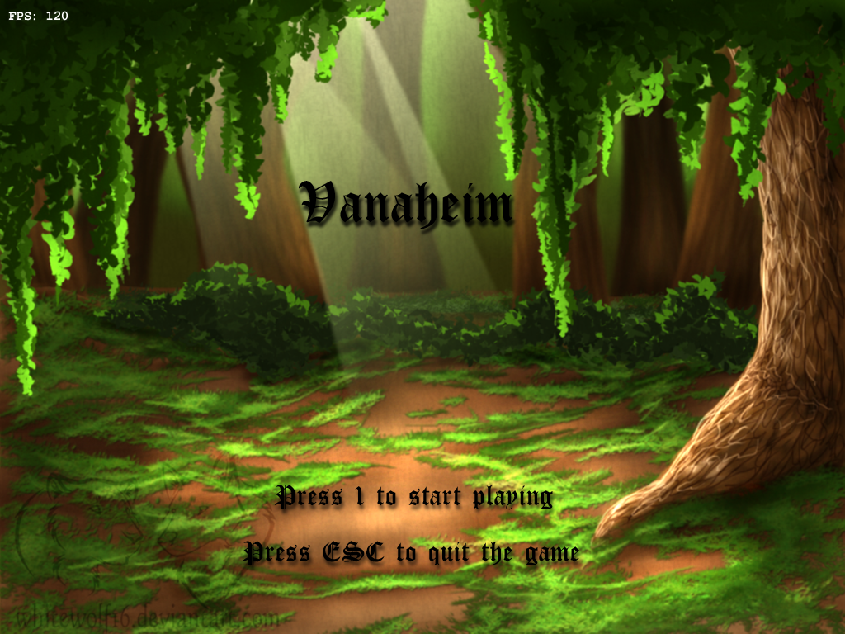
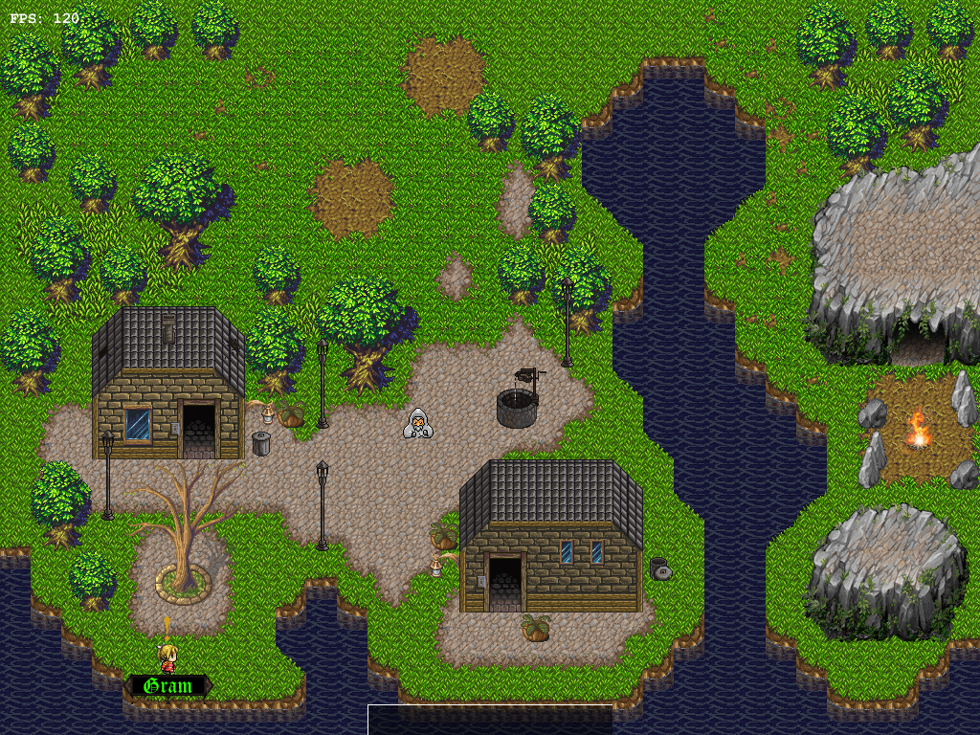
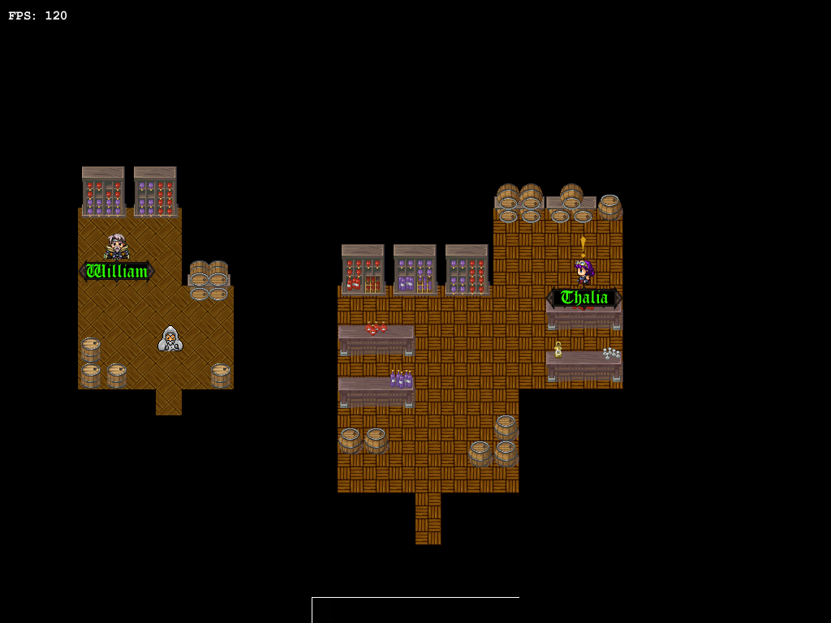
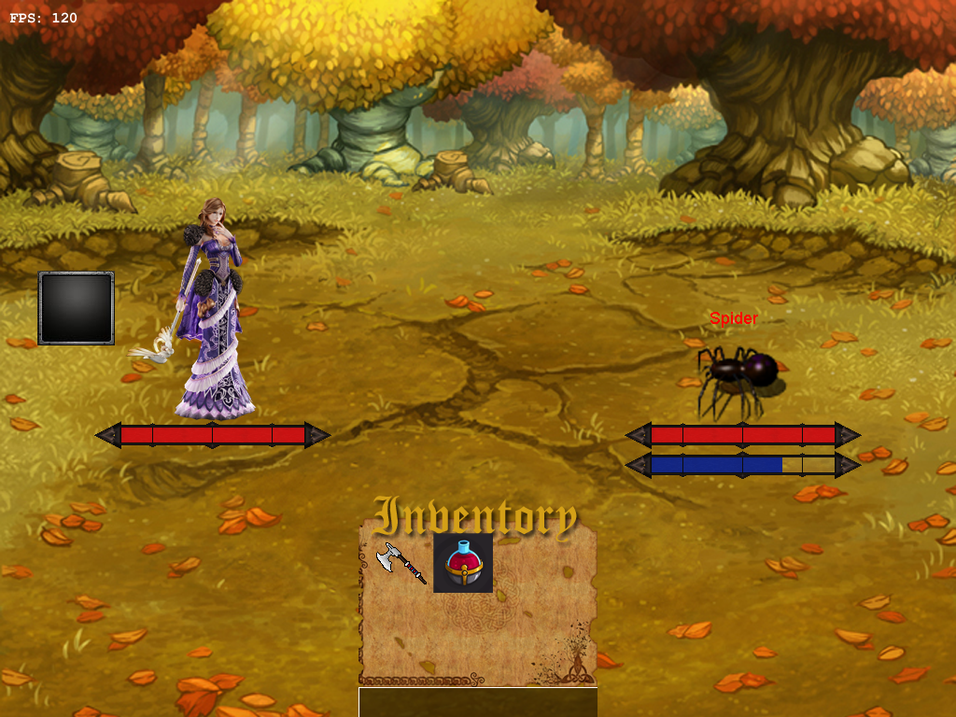

Analysis model


